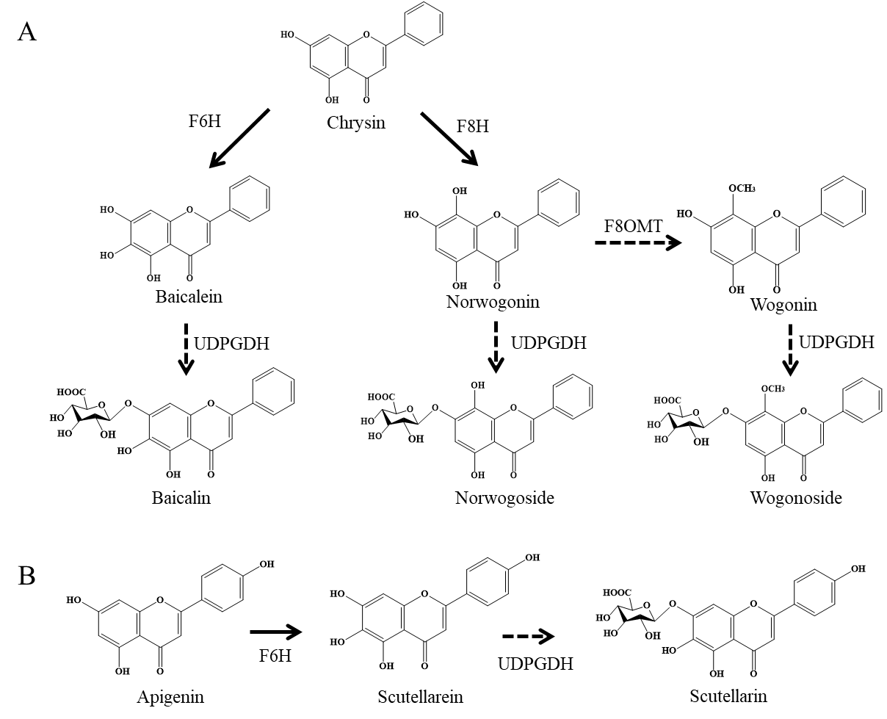

Supplementary Figure S15. The potential biosynthetic pathway of baicalein, scutellarein, wogonin, and their glycosides (baicalin, scutellarin, and wogonoside), catalyzing chrysin and apigenin.